Orgo Helper: Site User Flows
Oct 28, 2026 · @Sara

Purpose and scope
These flows cover every way a student reaches a practice session on orgohelper.com, plus the site-level pages around it. They are the first step of the design process: user flows → lo-fi wireframes → hi-fi mockups → clickable prototype.
The handoff point. Every practice flow ends at Generator page loaded: the site frame (header, menu, footer) with the chosen generator inside it. What happens next, including the IUPAC generator's settings-first first visit, belongs to each generator's own user flows and will be attached here later.
Not covered: anything inside a generator, and the Lectures content. Lectures is a static "Under construction" page for now.

Decisions these flows are built on
Topic | Decision
What's public | Home, Lectures (Under construction), Coming-soon pages, the Unavailable on a phone page and footer pages (About, Privacy, Terms, Contact).
What's gated | Every generator and the Account page. Reaching one signed-out opens Sign in.
After sign-in | The student returns to the page they were heading to, never a dashboard.
First-time users | No extra step. The account is created on first Google or Apple sign-in and they go straight in.
Phone visitors | The site works on phones. Each generator is either phone-friendly (simple interface) or desktop-only. A desktop-only generator opened on a phone shows a static Unavailable on a phone page instead. IUPAC naming is phone-friendly.
Coming-soon generators | Selectable. They open a static Coming-soon page that points to IUPAC practice and the videos.
Account page (MVP) | Profile info (name, email, Google or Apple), a practice-summary placeholder, Sign out, and Delete account (with a confirmation step).
Signed-out header | The Account menu item reads Sign in while signed out and Account once signed in. Sign in from the header returns the student to the page they were on.
Expired sign-in | If sign-in expires inside a generator, the student goes to Sign in with a "Please sign in again" message and returns to the same generator. How each generator handles work in progress is agreed with that generator's project.
Contact | A simple public contact form (name, email, message). Signed-in students get name and email filled in.
Broken links | Any unknown address shows a public Not found page that sends the student to the homepage.
Terms acceptance | A line next to the sign-in buttons ("By continuing, you agree to our Terms and Privacy Policy", with links). No checkbox for now; revisit when paid subscriptions are added.
Home page layout | Option D from the wireframes: a headline, then a Practice card listing every generator (IUPAC naming with Start, coming-soon topics as muted rows) and a Learn card for the videos. Stacked on phones, side by side on tablets and laptops.

Site map
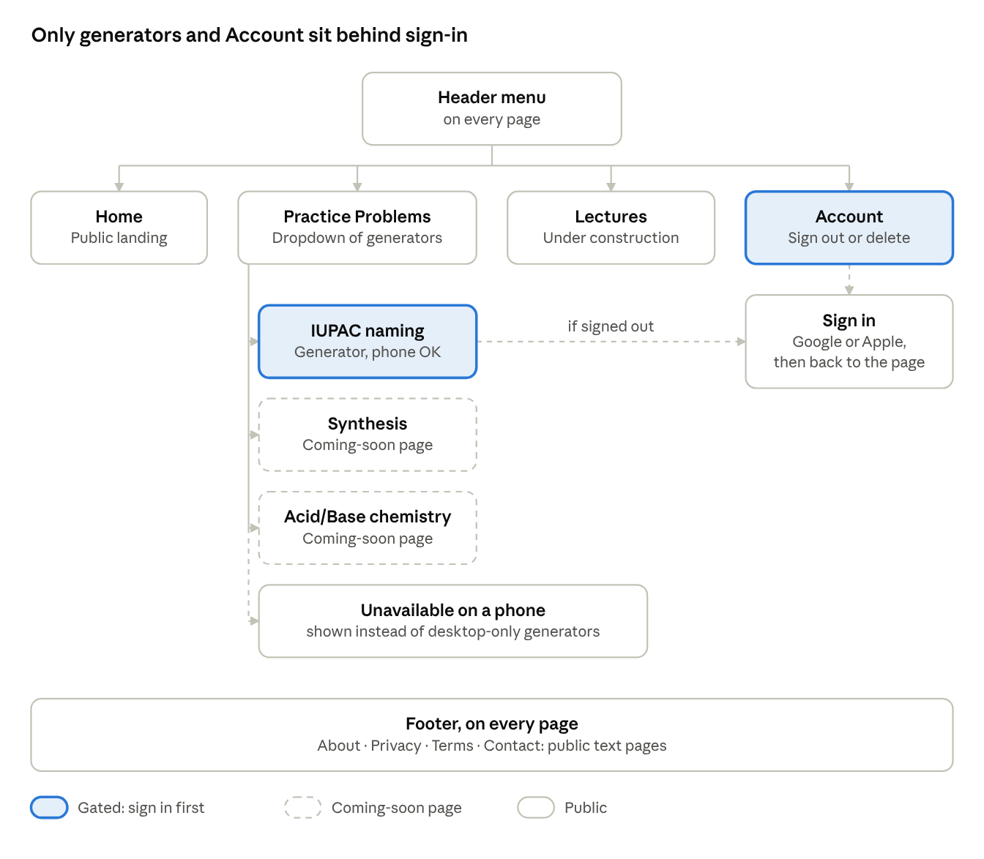
site map · header, footer and Unavailable on a phone page
Everything is reachable from the header menu or footer. Only the IUPAC generator and Account require sign-in; on a phone, a desktop-only generator is replaced by the Unavailable on a phone page.

Flows: starting a practice session
All three entry points share one path: availability check, then phone check (desktop-only generators only), then sign-in check, ending at Generator page loaded.
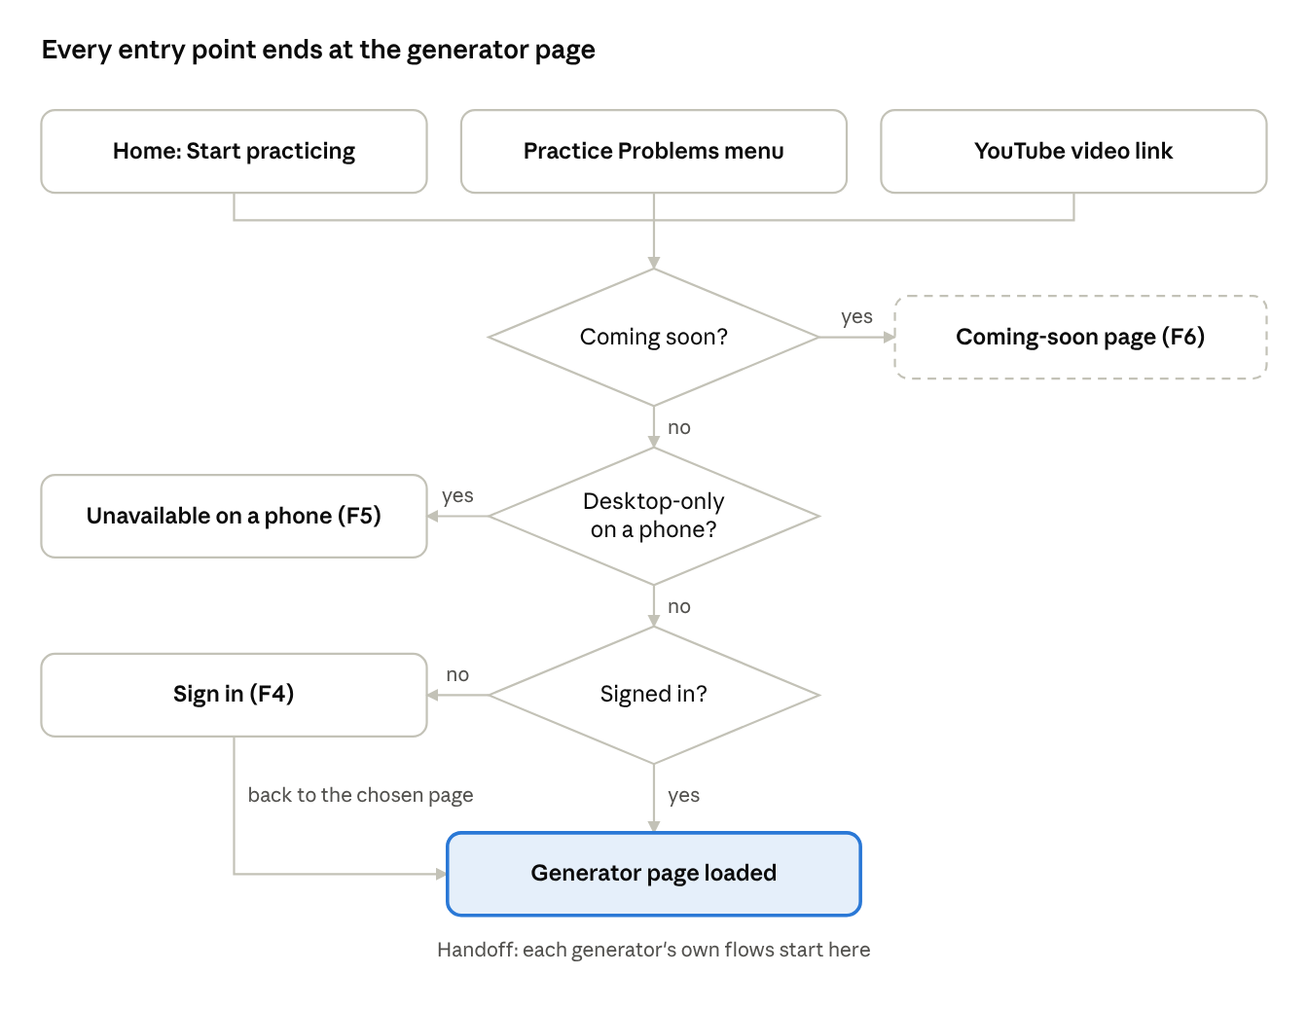
starting a practice session · 3 entry points, 3 checks

F1. From the home page
- Student lands on Home (signed in or not, on any device).
- In the Practice card's topic list, clicks Start on IUPAC naming.
  - A coming-soon row (Synthesis, Acid/Base chemistry) → F6.
- Desktop-only generator and the visitor is on a phone → Unavailable on a phone (F5).
- Signed in → Generator page loaded.
- Signed out → Sign in (F4), then Generator page loaded.

F2. From the Practice Problems menu (any page)
- Student opens Practice Problems in the header.
- Picks a generator from the dropdown.
  - Marked "Coming soon" → F6.
- Desktop-only generator and the visitor is on a phone → Unavailable on a phone (F5).
- Signed in → Generator page loaded.
- Signed out → Sign in (F4), then Generator page loaded.

F3. From a YouTube video (deep link)
- Student clicks the link in a video description, which points straight at one generator (for example, IUPAC naming).
- Desktop-only generator and the visitor is on a phone → Unavailable on a phone (F5).
- Signed in → Generator page loaded.
- Signed out → Sign in (F4), then Generator page loaded for that same generator.

F4. Sign in (shared step)
- Sign in page shows Continue with Google and Continue with Apple, the destination they'll return to, and a line that signing in accepts the Terms and Privacy policy.
- Student picks a provider and completes the provider's own screens.
- First-time user → account created silently; no extra screen.
- Success → redirect to the remembered destination. An expired sign-in uses the same path: Sign in shows "Please sign in again" and returns the student to the same generator.
- Cancelled or failed → back to Sign in with a short error message and both buttons.

Flows: the rest of the site

F5. Desktop-only generator on a phone
- Each generator is marked phone-friendly or desktop-only. Simple generators (IUPAC naming) work on phones; complex ones may not.
- A visitor on a phone picks a desktop-only generator from Home, the menu or a video link.
- Instead of the generator, the site shows the static Unavailable on a phone page, inside the site shell: "This feature is unavailable on a phone. Please revisit the page on a laptop or tablet."
- This check comes before sign-in, so nobody signs in for something they can't use. The header still lets them reach other pages.
- Phone-friendly generators and all other site pages open normally on phones.

F6. Coming-soon generator
- Student picks Synthesis or Acid/Base from the Practice Problems menu or the topic list on Home.
- Coming-soon page (public, no sign-in) shows the generator name, a one-line description and a "Coming soon" label.
- Next steps on the page: Start IUPAC practice → F1 from step 3, or Watch the videos → YouTube channel in a new tab.

F7. Lectures
- Student clicks Lectures in the header.
- Lectures: Under construction static page (public). Links back to Practice Problems and the YouTube channel.

F8. Account
- Student clicks Account in the header.
- Signed out → Sign in (F4), then back to Account. Signed out, this menu item reads Sign in; from there, Sign in returns the student to the page they were on.
- Account page shows name, email, the provider used, and a Practice summary area with an empty state ("Your scores will appear here").
- Sign out → signed out, returned to Home in its signed-out state.
- Delete account → Delete account confirmation, which explains that the account and saved practice data are removed immediately and permanently, and offers "Download my data" first. Once payments exist, an active subscription must be cancelled before this page allows deletion.
  - Cancel → back to the Account page, nothing changed.
  - Delete my account → account and data deleted, signed out, returned to Home with a short "Your account has been deleted" message.
  - Signing in again later with the same Google or Apple account creates a fresh account.

F9. Footer pages
- From any page footer: About, Privacy, Terms, Contact.
- About, Privacy and Terms each open a public static page; Privacy and Terms are also linked from the Sign in page.
- Contact opens the Contact form (public): name, email, message and Send. Signed-in students have name and email filled in.
  - Missing or invalid field → inline error, stays on the form.
  - Send → Message sent confirmation on the same page.

F10. Broken or outdated link
- Student opens an address that doesn't exist (for example, an old video link).
- Not found page (public, inside the site shell) says the page couldn't be found.
- Go to the homepage → Home.

Screen inventory for lo-fi wireframes
Fourteen screens and states to wireframe. Every screen sits inside the shared site shell (header with menu, footer). Since some generators work on phones, each screen also needs a phone layout.
# | Screen or state | Access | Used in | Key elements
1 | Home, signed out | Public | F1 | Headline and "Free. Sign in with Google or Apple"; Practice card with a topic list (IUPAC naming with Start, coming-soon rows); Learn card with videos (coming-soon panel for now)
2 | Home, signed in | Gated view | F1, F8 | Same as 1 without the sign-in line; header shows Account, and Start goes straight to the generator
3 | Practice Problems dropdown | Component | F2 | Generators with one-line description; coming-soon items labelled
4 | Sign in | Public | F4 | Google and Apple buttons, "You'll return to …", Terms/Privacy line
5 | Sign in, error | Public | F4 | Same as 4 with error message
6 | Generator page (frame) | Gated | F1–F3 | Site shell with an empty generator slot: the handoff point
7 | Coming-soon page | Public | F6 | Name, description, Coming soon label, Start IUPAC practice, Watch the videos
8 | Lectures: Under construction | Public | F7 | Message, links to Practice Problems and YouTube
9 | Account | Gated | F8 | Profile info, provider, Practice summary empty state, Sign out, Delete account
10 | Unavailable on a phone | Public | F5 | Static message: "This feature is unavailable on a phone. Please revisit the page on a laptop or tablet."; site header still available
11 | Footer pages (About, Privacy, Terms) | Public | F9 | One text-page template
12 | Delete account confirmation | Gated | F8 | What will be deleted, Download my data, Delete my account, Cancel; afterwards Home shows "Your account has been deleted"
13 | Contact form | Public | F9 | Name, email, message, Send; inline errors; Message sent confirmation state
14 | Not found | Public | F10 | Page-not-found message, Go to the homepage
Google and Apple's own sign-in screens are external and not wireframed.

Open questions
- ☐ Account deletion: users can now delete their account from the Account page (F8). Decided: delete immediately, with no grace period. Still to decide: what the Privacy policy says is removed.
- ☐ Account deletion once payments are added: update F8 to (1) if a subscription is active, ask the student to cancel it before they can delete; (2) offer "Download my data" (practice history, payment receipts) on the confirmation page; (3) delete immediately, with no grace period; (4) keep the billing records required for tax and accounting separately after the account is gone, and say so in the Privacy policy.
- ☐ Terms acceptance once payments are added: revisit adding an "I agree to the Terms" checkbox, at least at checkout for paid subscriptions.
- ☐ Phone support per generator: each generator project declares phone-friendly or desktop-only as part of the website–generator interface. IUPAC naming is declared phone-friendly.
- ☒ Vision doc update: the project vision still says laptop-first with no phone layout and describes the old phone notice; update it to match.
- ☒ Signed-out header: does the Account menu item read "Sign in" when signed out?
- ☒ Contact: a mailto link or a form?
- ☐ Contact form handling: where messages go (for example, emailed to you through AWS SES), spam protection (rate limit, hidden honeypot field), and a Privacy policy line on how contact details are used.
- ☒ Expired sign-in inside a generator: sign in again and return to the generator; agree how this works with each generator project.
- ☒ Broken deep links: add a Not found page that points to Practice Problems?
- ☒ Terms acceptance: decided: a line next to the sign-in buttons, no checkbox.

